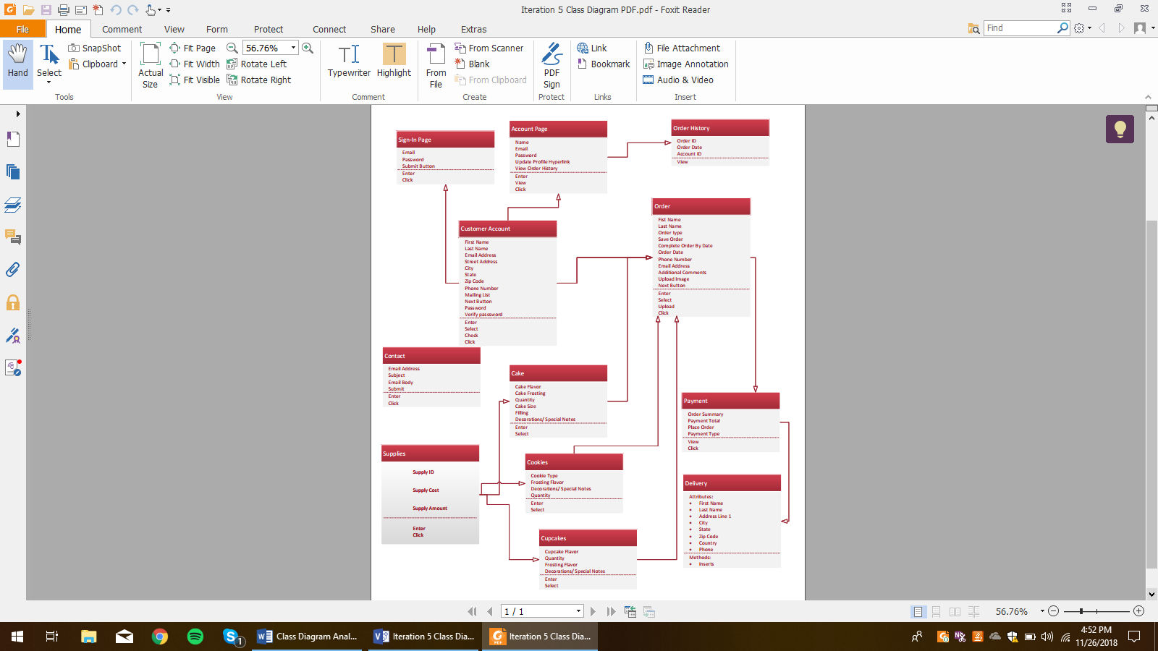

This class diagram depicts the various entities involved in the system for Sweet Karoline’s Cakes. Each table lists all of the necessary attributes and methods by which to input said attributes into the system. The arrows show the relationships between the entities e.g. the customer account entity feeds into the order entity, along with cookies, cupcakes, and cakes while the order entity feeds into payment. Some entities do not have any arrows around them indicating they do not share any relationships with the other depicted entities in the system.

|  |  |
| --- | --- |
| Class Name: Customer Account | Description: An account created by a customer where the customer’s information is inputted and stored. |
| Responsibilities: Create an account.  Update account.  Store account information. | Collaborations: Order, Account Page, Sign-In Page |
| Attributes: Everything except state, mailing list, and the next button are text fields. State is a drop box, mailing list is a check box, and the next button is a button. | Relationships: Associated with the Order, Account Page, and Sing-In Page classes. |

|  |  |
| --- | --- |
| Class Name: Order | Description: An order created by either a guest or existing customer account holder for Karoline to fulfill. |
| Responsibilities: Create an order.  Update order.  Store order information. | Collaborations: Customer Account, Cake, Cupcakes, Cookies, and Payment. |
| Attributes: Everything except Save Order, Complete order by date, upload image, and the next button are text fields. Save order is a check box, Complete order by date is a selection on a calendar, upload image is an attachment upload, and the next button is a button. | Relationships: Associated with customer account and payment. Has parts from Cake, Cupcakes, and Cookies. |

|  |  |
| --- | --- |
| Class Name: Payment | Description: After submitting an order for Karoline, the customer is taken to the payment form where they can choose their payment type and view their order summary. |
| Responsibilities: Store selected payment type.  Display order summary. | Collaborations: Order and Delivery. |
| Attributes: Order Summary and Payment Total are displayed, Payment type is selected via drop-down, and Place Order is a button. | Relationships: Inherits information from Order, inherited by Delivery. |

|  |  |
| --- | --- |
| Class Name: Delivery | Description: If the customer wishes for their order to be delivered, they are required to enter personal information for the request to be completed by Karoline or a third party. |
| Responsibilities: Store entered customer information. | Collaborations: Payment |
| Attributes: All attributes in the delivery entity are entered as text. | Relationships: If customer selects delivery they are directed to delivery page. |

|  |  |
| --- | --- |
| Class Name: Cake | Description: If a customer selects Cake in the Order Type part of the Order, they are tasked with selecting and inputting the cake information. |
| Responsibilities: Store selected cake specifications for customer order. | Collaborations: Order |
| Attributes: All attributes except for decorations/special notes are drop down boxes. Decorations/special notes is entered as text. | Relationships: All entered information is inherited by Order. |

|  |  |
| --- | --- |
| Class Name: Cupcake | Description: If a customer selects Cupcake in the Order Type part of the Order, they are tasked with selecting and inputting the cupcake information. |
| Responsibilities: Store selected cupcake specifications for customer order. | Collaborations: Order |
| Attributes: All attributes except for decorations/special notes are dropdown boxes, decorations/special notes are inputted as text. | Relationships: All information is inherited by Order after inputting. |

|  |  |
| --- | --- |
| Class Name: Cookies | Description: If a customer selects Cookies in the Order Type part of the Order, they are tasked with selecting and inputting the cookie information. |
| Responsibilities: Store selected cookie specifications for customer order. | Collaborations: Order |
| Attributes: All attributes except for decorations/special notes are dropdown boxes, decorations/special notes are inputted as text. | Relationships: All information is inherited by Order after inputting. |

|  |  |
| --- | --- |
| Class Name: Contact | Description: The contact entity is for customers who want to contact Karoline via email via link on the homepage. |
| Responsibilities: Send an email to Karoline from a customer. | Collaborations: None |
| Attributes: All attributes are entered as text except for the submit button, which is clicked. | Relationships: None |

|  |  |
| --- | --- |
| Class Name: Supplies | Description: The supplies entity is for Karoline to be able to keep track of the supplies she is using for her business. |
| Responsibilities: Store entered supply purchases. | Collaborations: Cookies, Cupcakes, and Cakes |
| Attributes: All attributes are entered as text. | Relationships: Cookies, Cupcakes, and Cakes |

|  |  |
| --- | --- |
| Class Name: Sign-In Page | Description: The sign-in page entity is for when customers sign in to their account after accessing the home page. |
| Responsibilities: Match login credentials with existing account.  Allow user access to account after credentials have been verified. | Collaborations: Customer Account |
| Attributes: All attributes are entered as text besides the Submit Button which is clicked. | Relationships: The Sign-In page entity is directly related to the Customer Account class since it has to match credentials to a specific account. |

|  |  |
| --- | --- |
| Class Name: Account Page | Description: The account page allows customers with an existing account to view and edit their account information and any previous orders. |
| Responsibilities: Allow customers to view and update their account information and provide access to previous orders. | Collaborations: Customer Account and Order History |
| Attributes: All attributes are viewed initially, if a customer updates any information it is entered as text. | Relationships: The Account Page entity is directly related to Customer Account since that is where all viewable information is inherited from. The Account Page is also related to Order History. |

|  |  |
| --- | --- |
| Class Name: Order History | Description: The Order History entity displays any previous orders a customer has made with their account. |
| Responsibilities: Display previous orders. | Collaborations: Account Page |
| Attributes: All attributes are displayed for viewing. | Relationships: Order History is directly related to Account Page. |